**DJANGO CHANNELS-API WEBSOCKET NODEJS CLIENT**

**REF:**

<https://www.npmjs.com/package/websocket>

<http://django-tornado-websockets.readthedocs.io/en/latest/usage.html>

<https://stackoverflow.com/questions/14933235/access-golang-websocket-server-with-nodejs-client>

FIRST WE NEED TO INSTALL ***websocket*** USING NPM:

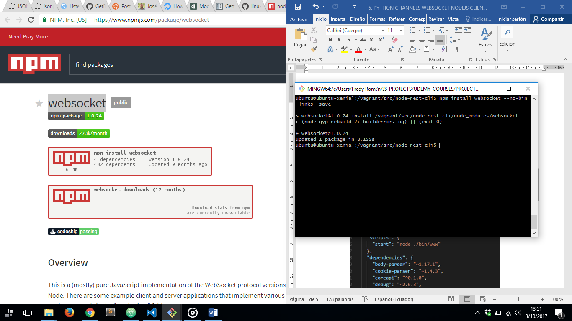

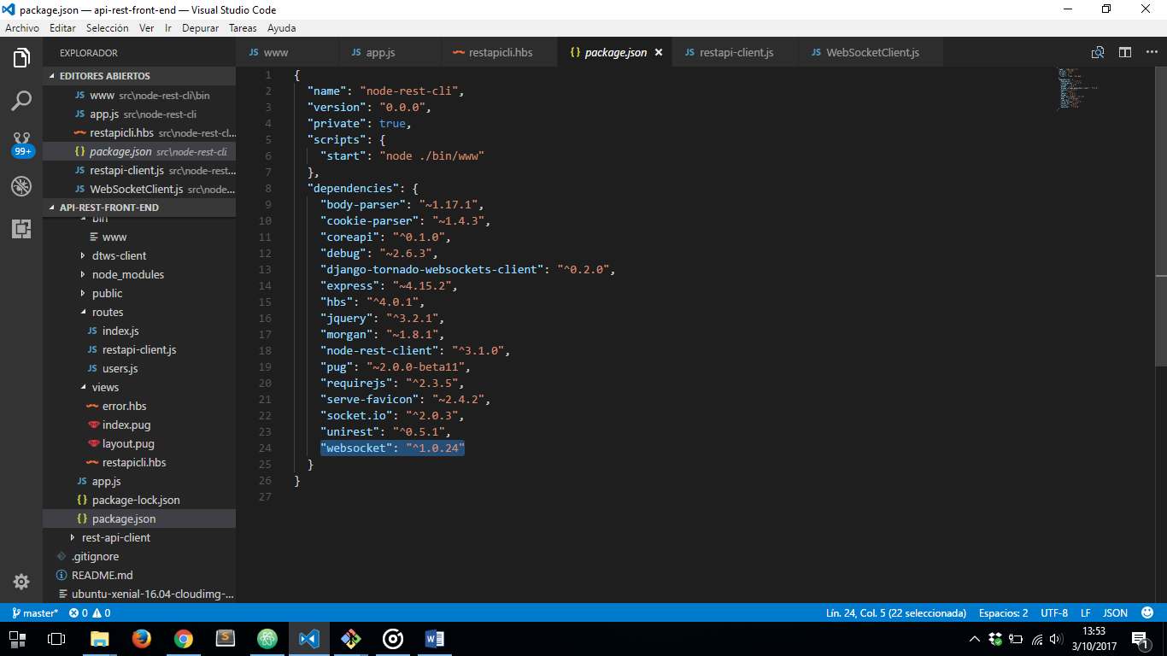

NEXT WE HAVE TO DO IS CONFIGURE OUR DJANGO CHANNELS WEBSOCKET NODEJS CLIENT

***app.js*** FILE

1. REQUIRING WEBSOCKET
2. HANDLING ERRORS
3. HANDLING CONNECTION
4. SUBSCRIBING TO CHANNELS API WEBSOCKET NOTIFICATIONS
5. GETTING DATA COMMING FROM CHANNELS API WEBSOCKET AND SENDING IT THROUGH SOCKET.IO TO FRONT END CLIENT
6. HANDLING CONNECTION CLOSED
7. CONNECTING TO WEBSOCKET SERVER

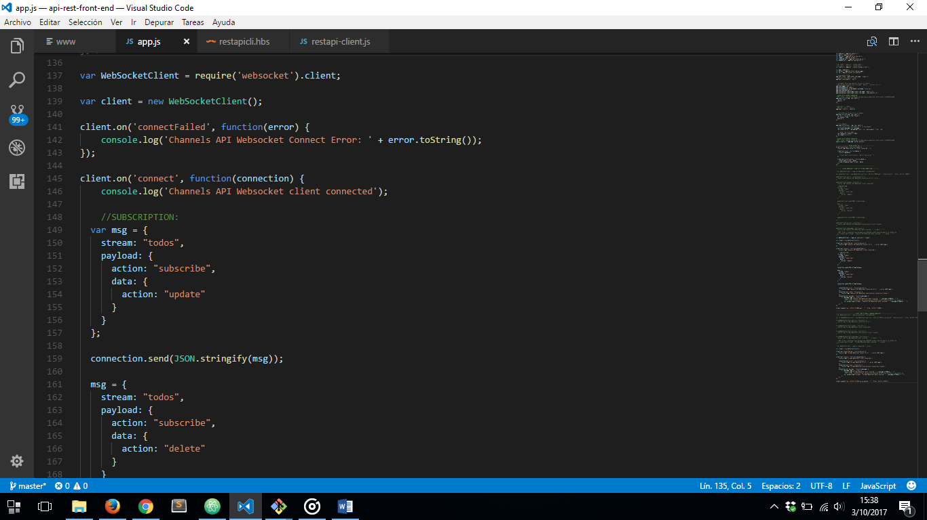

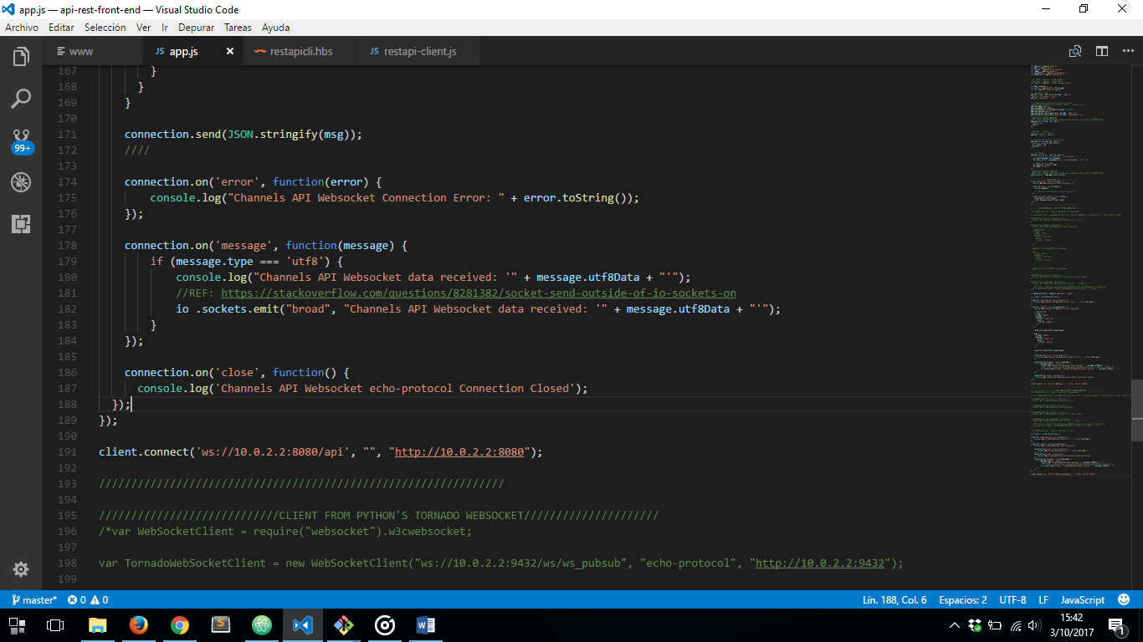

AND LET’S SEE ALL THIS RUNNING

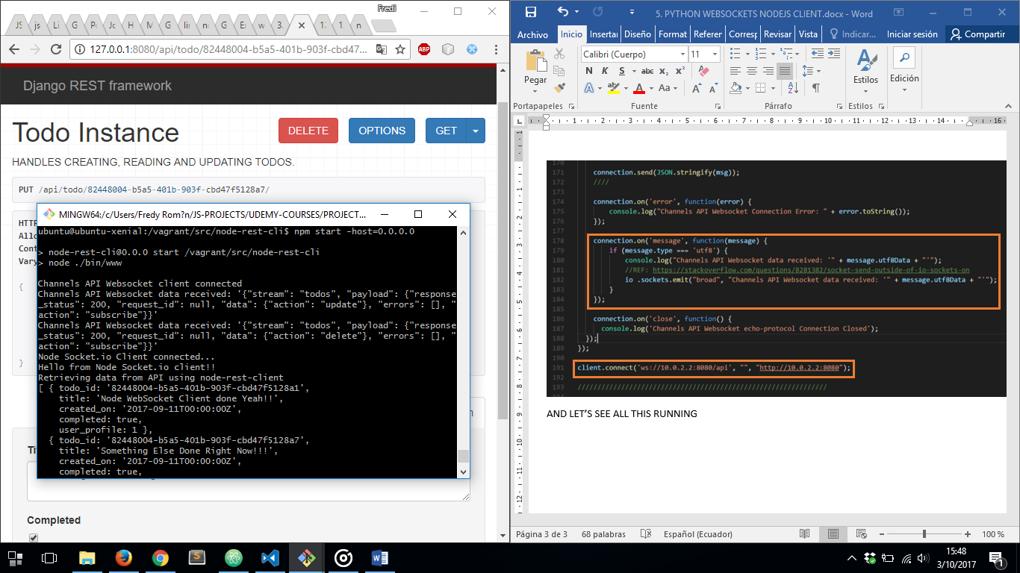

LET’S MAKE A CHANGE IN OUR REST API:

BEFORE:

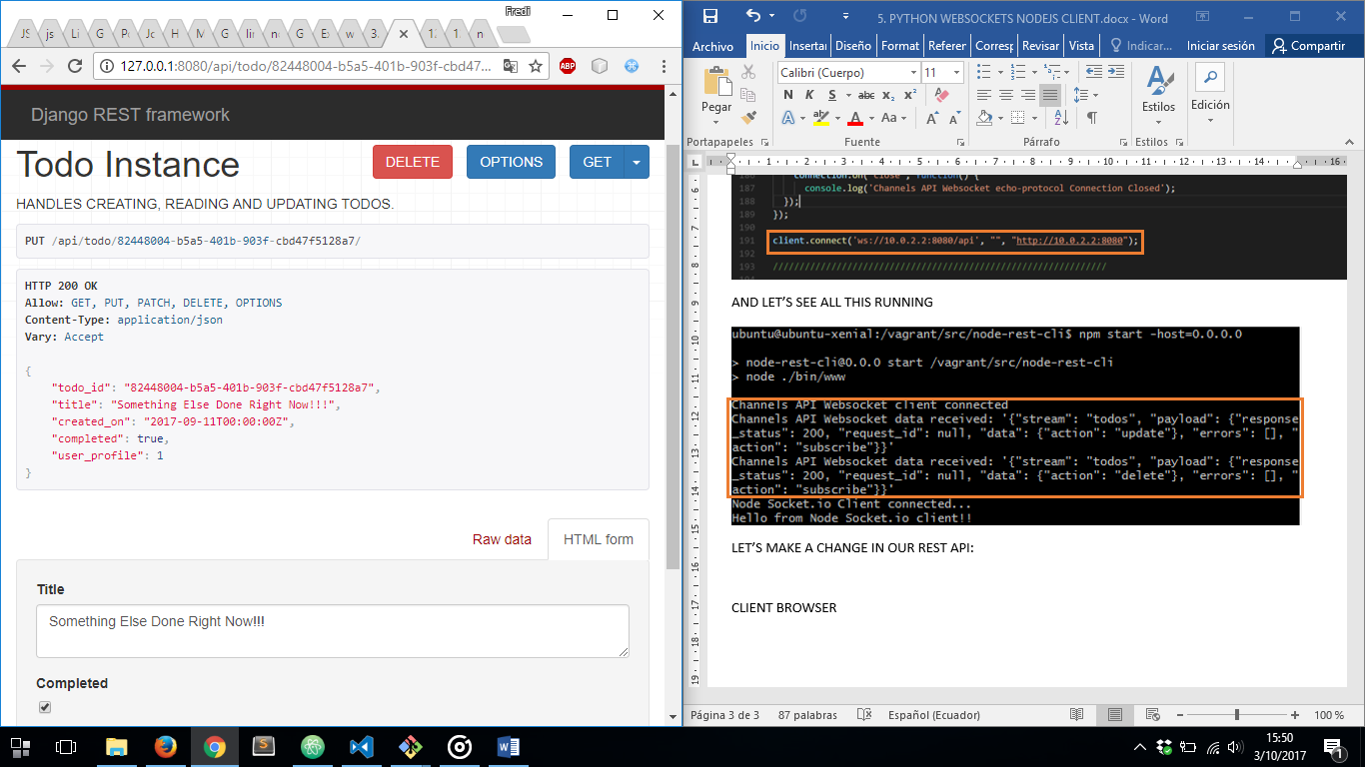

AFTER:

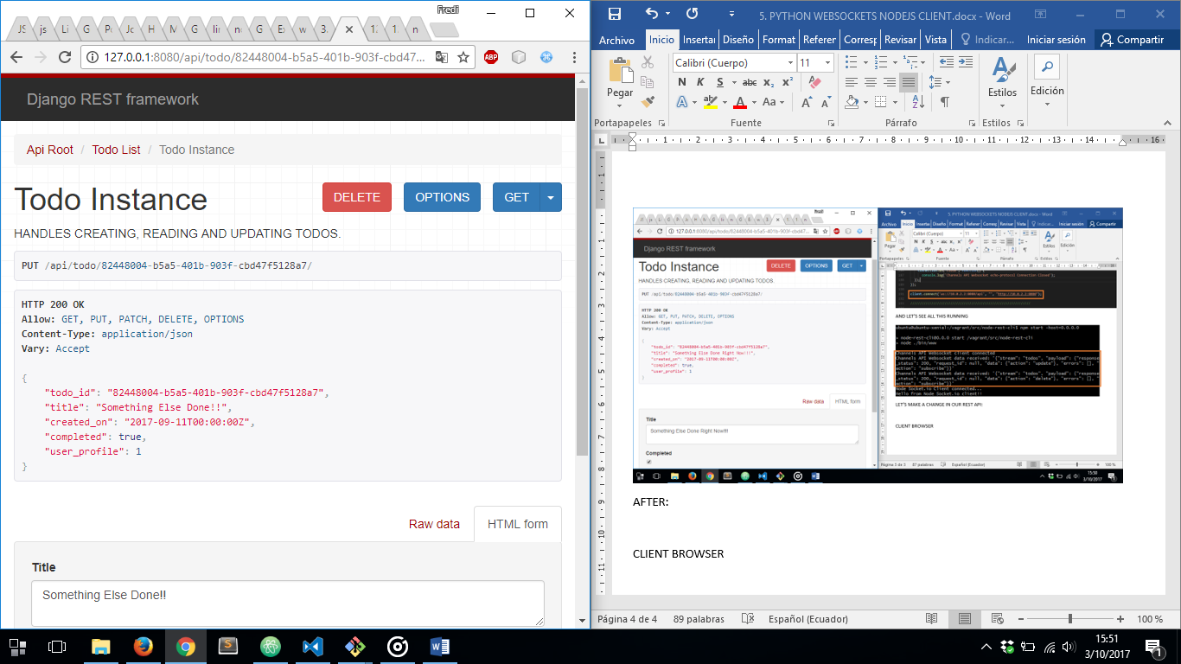

AND IN CLIENT BROWSER:

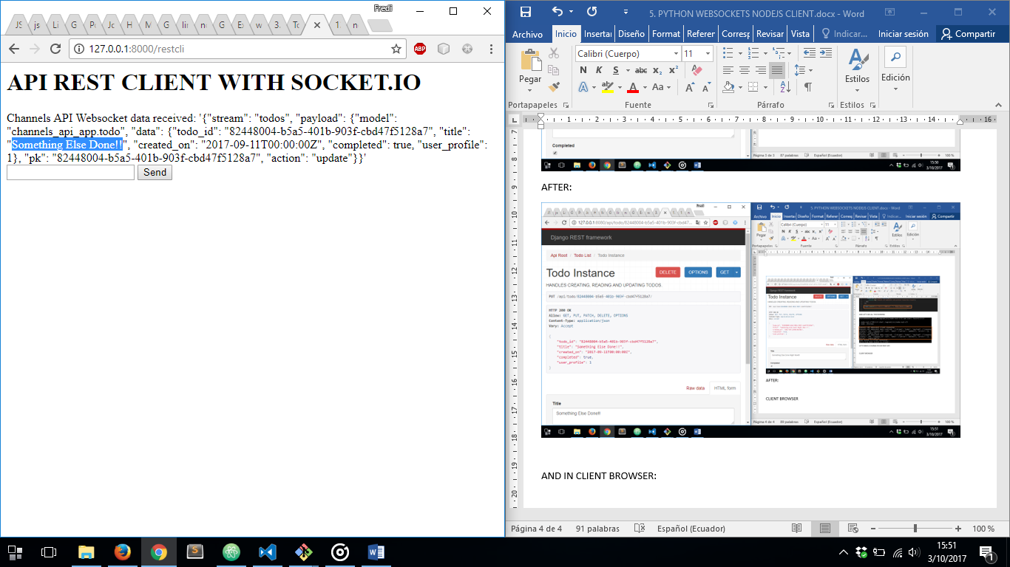

**TORNADO WEBSOCKET POSTGRESQL PG-PUBSUB NODEJS CLIENT**

***app.js*** FILE

1. REQUIRING WEBSOCKET MODULE
2. CREATING A NEW INSTANCE
3. HANDLING ERRORS
4. HANDLING CONNECTION
5. HANDLING CONNECTION CLOSED
6. GETTING DATA FROM POSTGRESQL NOTIFICATIONS THROUGH TORNADO WEBSOCKET AND SEND IT VIA SOCKET.IO TO FRONT END CLIENT
7. CONNECTING TO TORNADO WEBSOCKET

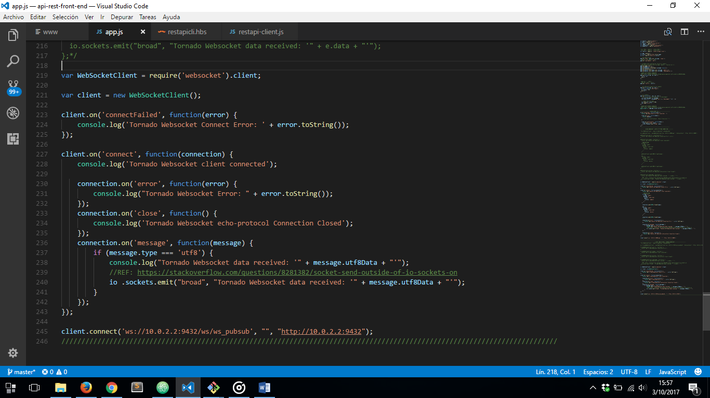

**NOTE:** IN THE LINK URL WE’VE SPECIFIED WE HAVE PUT ***“/ws/”*** BEFORE OUR TORNADO WEBSOCKET INSTANCE NAME. TORNADO WEBSOCKET INSTANCE NAME MUST BE THE SAME WE SPECIFIED IN OUR BACKEND:

***websocket/pubsub.py*** FILE:

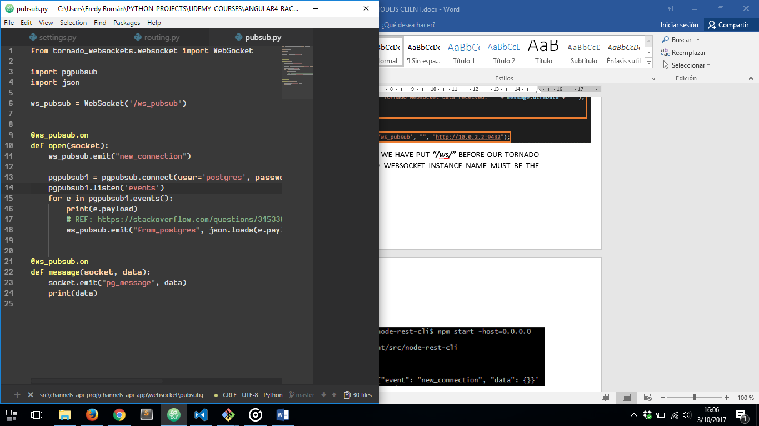

AND LET’S SEE IT RUNNING AGAIN:

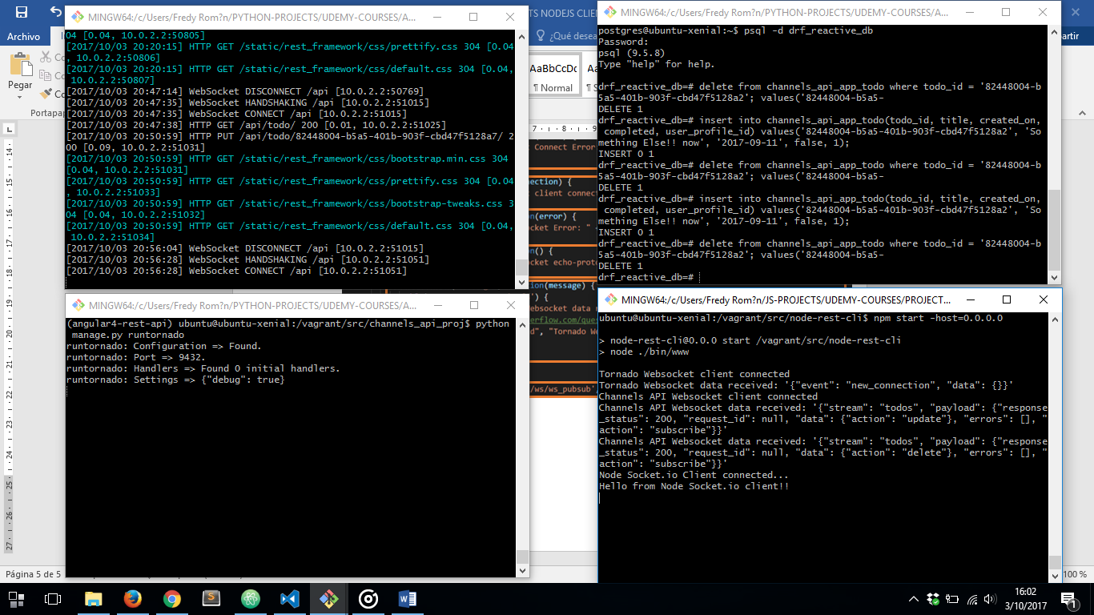

LET’S GO AHEAD AND MAKE ANY CHANGE IN OUR POSTGRESQL DB DIRECTLY AND SEE WHAT HAPPENS:

PSQL:

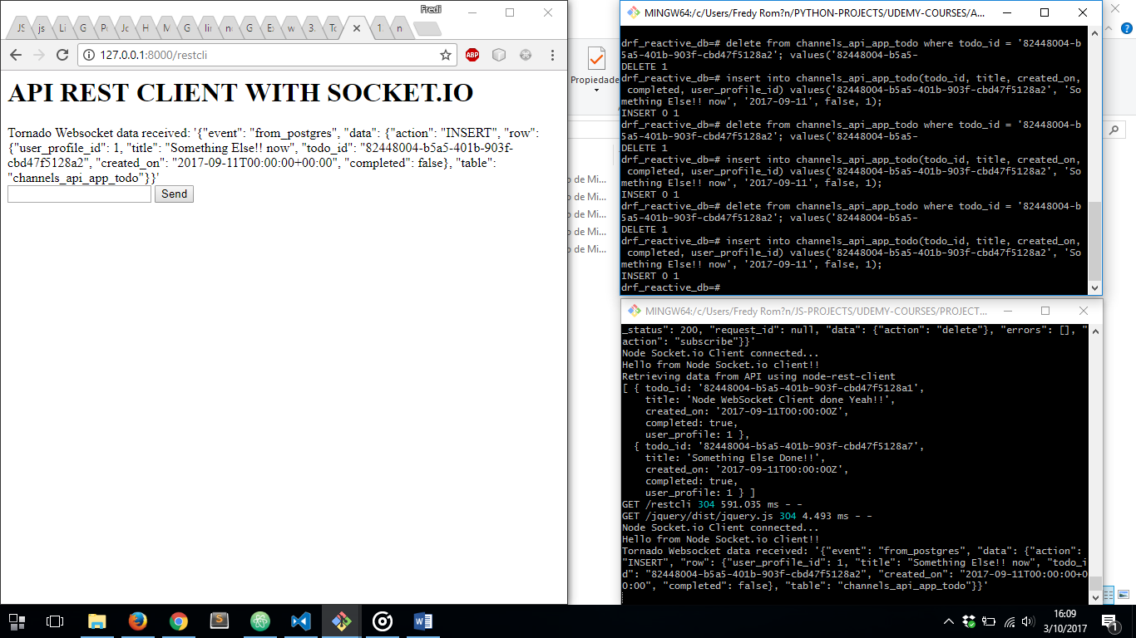

GETTING NOTIFICATION FROM NODEJS SERVER:



BROWSER SOCKET.IO CLIENT:

